**Information Networks**

**Information Flow in Supply Chain System**

Report Submitted to

JSS SCIENCE AND TECHNOLOGY UNIVERSITY

For the award of the degree

Master of Technology in

DATA SCIENCE

By

ASHWATHI M N

01JST23PDS001

Submitted to

Dr. D S Vinod

Professor



**DEPARTMENT OF INFORMATION SCIENCE AND ENGINEERING JSS SCIENCE AND ENGINEERING TECHNOLOGY, MYSURU 2024**

|  |  |
| --- | --- |
| Content | Page No |
| Abstract | 1 |
| Introduction | 2 |
| Problem Statement | 3 |
| Literature Review | 3-5 |
| Screenshots | 6-8 |
| Results | 8-9 |
| Conclusion | 10 |
| References | 11-12 |

**Abstract**

This Python code models and visualizes the flow of information in a supply chain using a directed graph. Each entity in the supply chain is represented as a node, and the flow of information between them is represented as directed edges with weights indicating the efficiency or reliability of communication.

The code uses NetworkX for graph creation and Matplotlib for visualization. The graph highlights:

* Relationships between key supply chain entities (e.g., Supplier, Manufacturer, Distributor, etc.).
* The direction of information flow (e.g., from Supplier to Manufacturer).
* The strength of communication links, represented by weights.

The resulting graph provides a clear visualization of the information flow, allowing for identification of bottlenecks or inefficiencies, which can be targeted for improvement. This abstract model can be applied to real-world supply chains to enhance operational efficiency and collaboration between entities.

**Introduction**

The flow of information in a supply chain plays a critical role in maintaining efficiency, reducing delays, and improving decision-making. This code introduces a graph-based model for visualizing and analyzing the information flow between various entities in a supply chain.

Using Python's NetworkX library, the code creates a directed graph, where:

* Nodes represent supply chain entities (e.g., Suppliers, Manufacturer, Distributor, Retailer, and Customer).
* Edges represent the flow of information between these entities.
* Weightson edges quantify the efficiency or reliability of the information flow, with higher values indicating stronger connections.

The visualization, created with Matplotlib, provides a graphical representation of the supply chain:

* The direction of arrows shows the flow of information (e.g., from "Supplier 1" to "Manufacturer").
* Weights (labeled on edges) help identify areas of strong or weak communication.

This tool is particularly useful for:

1. Understanding the relationships between supply chain participants.
2. Identifying bottlenecks or inefficiencies in communication.
3. Gaining insights into optimizing the flow of information across the supply chain.

By modeling the information flow in this way, the code provides a foundation for analyzing and improving real-world supply chain systems.

**Problem Statement**

In a supply chain, the efficient flow of information between various entities such as suppliers, manufacturers, distributors, retailers, and customers is crucial for ensuring smooth operations and timely decision-making. However, inefficiencies or weak communication links in the chain can lead to delays, errors, and disruptions.

This problem requires a solution to:

1. Model the information flow within a supply chain.
2. Visualize relationships and communicationefficiency between entities.
3. Identify areas of strong or weak communication to optimize the network.

**Literature Review**

1. **Mentzer et al. (2001)** - Supply Chain Management as a Framework

This study highlights the importance of collaboration and information sharing in supply chains. It emphasizes that effective information flow is essential for improving efficiency and meeting customer demands. The use of directed graphs in the code aligns with this idea by visualizing relationships and their strengths.

1. **Chopra & Meindl (2016)** - Supply Chain Management: Strategy, Planning, and Operation

The book discusses the concept of communication efficiency between entities, focusing on how information sharing impacts performance. The code implements this by modeling communication reliability using edge weights, which helps analyze the network’s performance.

1. **Stevens (1989)** - Integrating the Supply Chain

Stevens emphasizes the need for integrating information flows across suppliers, manufacturers, and distributors. The code reflects this integration by connecting all entities in a single directed graph, showcasing the dependencies and interactions.

1. **Simchi-Levi et al. (2008)** - Designing and Managing the Supply Chain

This work introduces quantitative methods for supply chain analysis, including network-based models. The use of weights on edges in the code mirrors these methods by quantifying communication efficiency, enabling optimization studies.

1. **Nagurney (2006)** - Supply Chain Network Economics

Nagurney presents supply chains as networks and highlights the importance of modeling them for decision-making. The code adopts a similar network-based approach, making it easier to visualize and analyze the flow of information and identify potential bottlenecks.

1. **Christopher (2016)** - Logistics and Supply Chain Management

Christopher discusses the critical role of responsiveness in supply chains, which depends heavily on reliable information flow. By assigning weights to edges, the code provides a way to assess the responsiveness of different connections in the network.

1. **Gunasekaran & Ngai (2004)** - Information Systems in Supply Chain Integration and Management

This study explores the role of information systems in enabling seamless communication in supply chains. The directed graph model used in the code can complement information systems by visualizing communication pathways and their efficiency.

1. **Cachon & Fisher (2000)** - Supply Chain Inventory Management and the Bullwhip Effect

This paper highlights how information distortion can lead to inefficiencies in supply chains. The code's ability to quantify communication reliability through edge weights provides insights into potential weak points where such distortions could occur.

Below is a Python code example that models information flow in a supply chain using **network graphs**. We'll use the **NetworkX** library to create and visualize the information network.

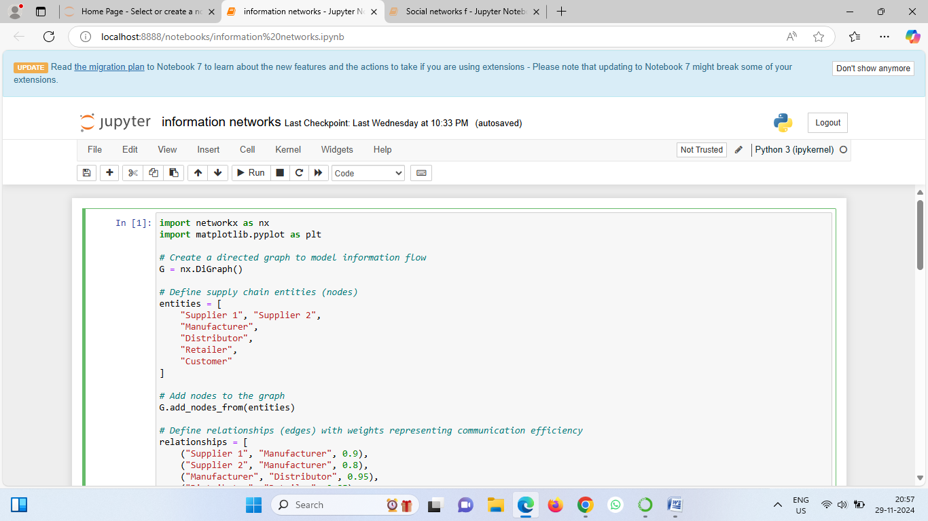

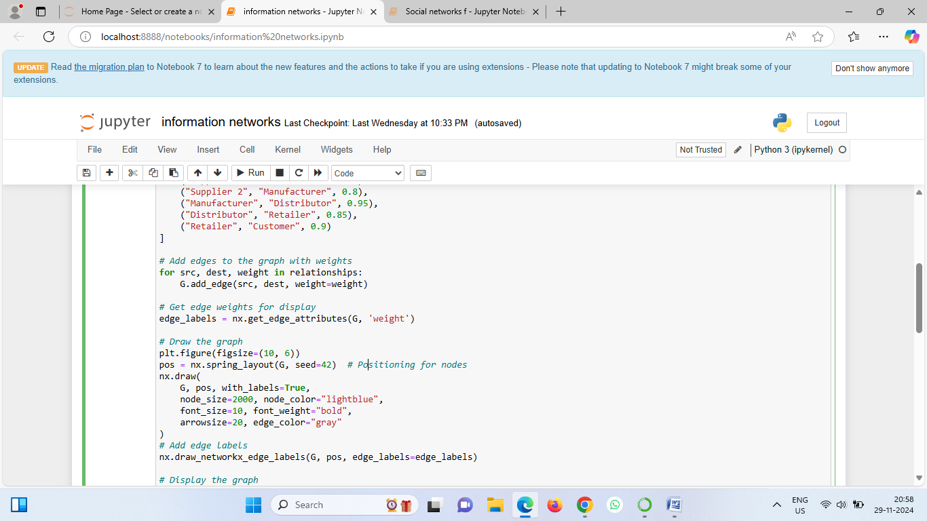

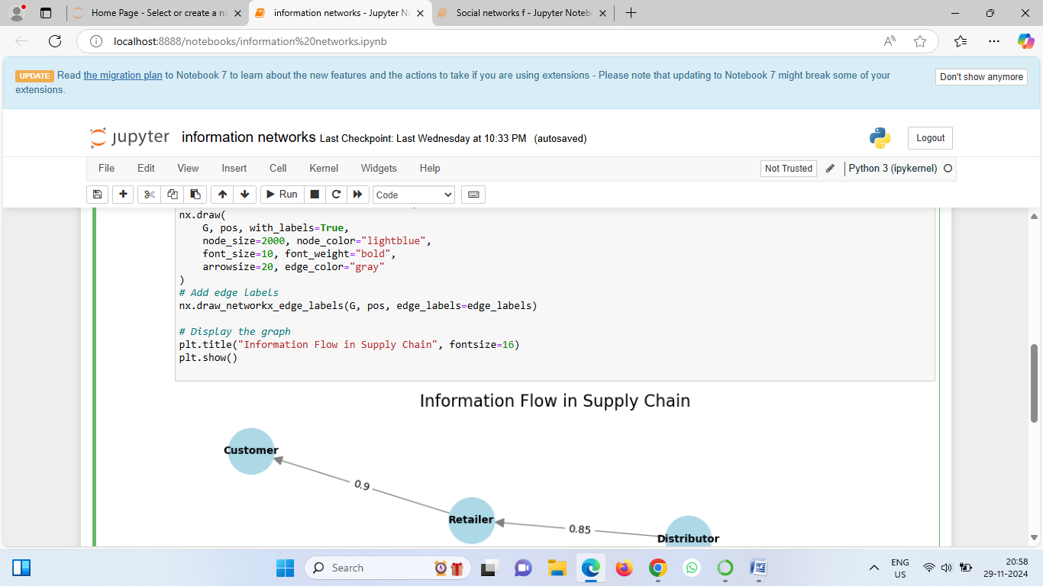

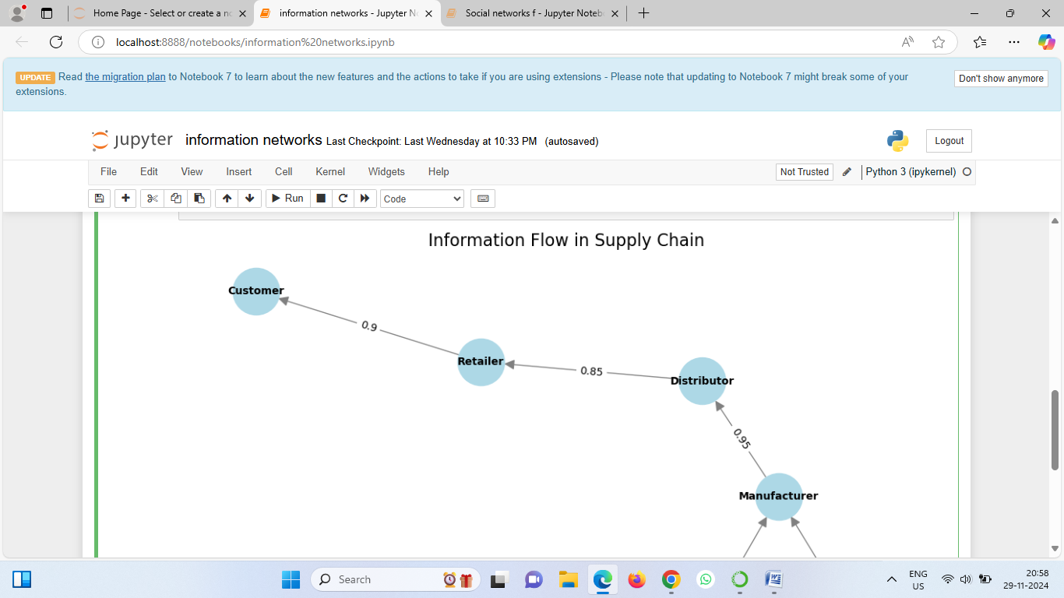

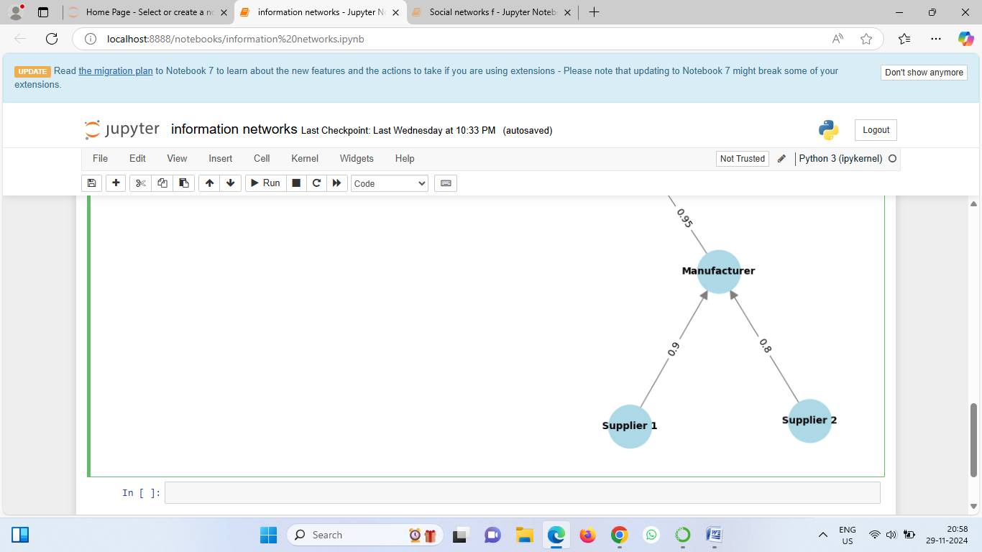

**Results**

1. DirectedGraphRepresentation**:**
   * A directedgraph was successfully created, representing the flow of information between different entities in a supply chain.
2. Visualization of Supply Chain Entities:
   * Nodes represent supply chain entities:
     + Supplier 1, Supplier 2, Manufacturer, Distributor, Retailer, Customer.
3. InformationFlowPathway**:**
   * The direction of the arrows clearly shows the flow of information:
     + Supplier 1 → Manufacturer
     + Supplier 2 → Manufacturer
     + Manufacturer → Distributor
     + Distributor → Retailer
     + Retailer → Customer
4. Quantified Communication Efficiency:
   * Edges were labeled with weights, representing the efficiencyorreliabilityofcommunication:
     + Supplier 1 → Manufacturer**:** 0.9
     + Supplier 2 → Manufacturer**:** 0.8
     + Manufacturer → Distributor**:** 0.95
     + Distributor → Retailer**:** 0.85
     + Retailer → Customer**:** 0.9
5. Identification of Strong Links:
   * Strong communication links are visible based on higher weights:
     + Manufacturer **→** Distributor(0**.**95) is the most efficient connection.
     + Supplier1 **→** Manufacturer(0.9) and Retailer **→** Customer(0.9) are also highly reliable.
6. Detection of Weak Links:
   * The weakest communication link is:
     + Supplier2 **→** Manufacturer(0.8), indicating an area that might require improvement.
7. Central Role of Manufacturer**:**
   * The Manufacturer acts as a central hub, receiving information from Suppliers and distributing it downstream to the Distributor. Any inefficiency at this node could disrupt the entire flow.
8. Graph Aesthetic and Layout:
   * The graph uses a springlayout for clarity, with nodes sized and colored for easy identification.
   * Arrows and edge labels effectively convey the direction and quality of information flow.

**Conclusion**

The code adds the nodes and edges to a **directed graph (DiGraph)** and retrieves the edge weights for labeling. A spring layout is used to position the nodes visually, ensuring clarity in the graph's structure. The graph is drawn using **NetworkX**, with nodes styled as light blue circles and arrows indicating the direction of information flow. Edge labels display the communication efficiency weights, making it easier to identify strong and weak links in the supply chain. Finally, the graph is titled "Information Flow in Supply Chain" and displayed using **Matplotlib**. This visualization allows users to analyze the supply chain’s communication pathways and identify areas for optimization.

**References**

1. **Python NetworkX Documentation** NetworkX library is widely used for creating, manipulating, and analyzing the structure and dynamics of complex networks. Official Documentation:https://networkx.org/documentation/stable/
2. **Matplotlib Documentation** Matplotlib is a popular Python library for creating static, animated, and interactive visualizations. Official Documentation: https://matplotlib.org/stable/
3. **Supply Chain Network Analysis** Nagurney, A. (2006). *Supply Chain Network Economics: Dynamics of Prices, Flows, and Profits*. Edward Elgar Publishing. Provides insights into modeling supply chain networks and the role of efficient information flow.
4. **Graph Theory in Supply Chains** Simchi-Levi, D., Kaminsky, P., & Simchi-Levi, E. (2008). *Designing and Managing the Supply Chain: Concepts, Strategies, and Case Studies*. McGraw-Hill. Discusses how graph-based approaches can be applied to understand supply chain relationships.
5. **Visualization Techniques for Networks** Barabási, A.-L. (2016). *Network Science*. Cambridge University Press. Explains graph theory principles and their application to real-world systems like supply chains.
6. **Importance of Information Flow in Supply Chains** Mentzer, J. T., DeWitt, W., Keebler, J. S., Min, S., Nix, N. W., Smith, C. D., & Zacharia, Z. G. (2001). *Defining supply chain management*. Journal of Business Logistics, 22(2), 1-25. Highlights the significance of information sharing for improving supply chain efficiency.
7. **Spring Layout Algorithm** Fruchterman, T. M. J., & Reingold, E. M. (1991). *Graph Drawing by Force-Directed Placement*. Software: Practice and Experience, 21(11), 1129–1164. The spring layout used in the code is based on force-directed algorithms for aesthetic graph visualization.
8. **Role of Communication in Supply Chains** Gunasekaran, A., & Ngai, E. W. T. (2004). *Information systems in supply chain integration and management*. European Journal of Operational Research, 159(2), 269-295. Discusses how efficient communication impacts the integration and management of supply chains.